**CIS207L – Course Project**

In this course, you will be creating a single project, which will use the skills you have learned about routing and switch as well as network security. Your project will be in groups no larger than four people and no smaller than two. Your project will have deliverables each week that will be uploaded to Canvas as a group.

You will also keep a weekly journal explaining, in detail, what you have done on the project and your input into your group. This journal will be updated each week and uploaded to Canvas. At the end of this class, your journal will be uploaded to Chalk and Wire for grading.

**Deliverables for the project**

Week 2 – Network design and network outline including new equipment that needs to be purchased for the project as well as goals for the project. You will need to create a “working model” in Packet tracer of the new network.

Week 3 – A functioning model of the project in Packet Tracer, on physical equipment, and an explanation of the working features.

Week 4 – A “non-technical” PowerPoint presentation (6-10 slides in length) that will be presented to the approving staff.

Week 5 – The final “technical” presentation which will be given to the professor and class during the 5th week of class. The presentation will need to show how your project meets the objectives of the project and complies with all state and federal regulations.

**The Project**

Three medical offices have decided to merge into a single working group. These offices have been cited with HIPAA code violations that, unless they are corrected, will cost the companies more than $500,000 is fines. Turn-around time is very short as the HIPAA auditor is visiting the locations in 6 weeks. The doctors have contracted with you to correct their failed network and set security in place so they can pass their HIPAA audit. Your budget is limited but they are willing to spend what is necessary to keep their offices open.

The current network:

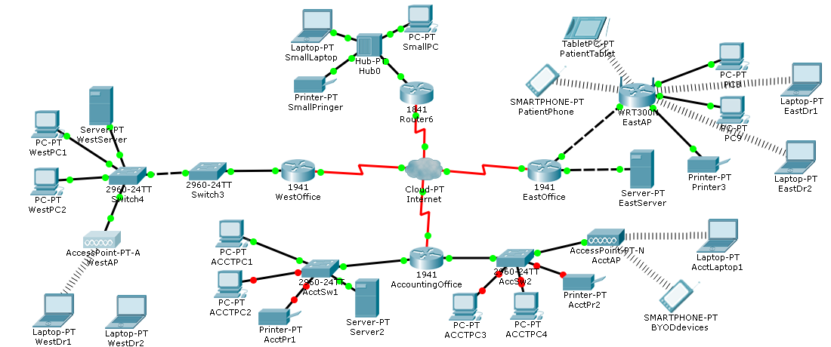

There are four offices:

The office networks include four offices that are all connected via cloud services.

West Office - 10 Employees + 2 Dr Laptops

* Includes one router that connects to a switch (switch 3).
* Switch 3 is connected to switch four, which is connected to a server, two PCs and a wireless access point to two doctor laptops.

East Office - 12 Employees + 2 Dr Laptops + patient wireless access to the internet

* Includes one router that is connected to a server and wireless router.
* The wireless router connects to two laptops, two PCs, and to patient devices.

Small Office – four Employees – no wireless

* Includes one router (router 6) that is connected to a hub, which is connected to a laptop, PC and a printer.

Accounting Office – 35 Employees + Wireless access for laptops and employee BYOD devices.

* Router of the South office is connected to two switches.
  + Switch 1 connects two pcs, printer and a server.
  + Switch 2 connects to two pcs, a printer, and a wireless router, which connects to two laptops and to patient devices.

The new group would like the following in their new network:

* Expand the number of laptops so doctors can carry their own from location to location.
* Allow patients access to the Internet through the network (it has been very popular in the East Office).
* Give security to the network (required) especially the servers which contain patient records and charts.
* Allow the network to expand to include more offices (we are in negotiations with two other offices to join the group).
* Keep cost as reasonable as possible.
* Give a presentation of the network for the HIPAA audit in 6 weeks.
* Allow our employees to connect to the network using their BYOD devices.
* The network has been “shaky at best” with service being intermittent at some locations. Make the network reliable.
* There are many other doctors’ offices in the area that are having similar issues. They are looking at this project for its results.

**Week 2**

You will design a network including all of the security measures required as well as the entire user request possible. You will need to give a list of all equipment needed and how it will be connected into your network. You should include the equipment and ports for each office. You will need to create a new Packet tracer network with the equipment and connections showing. You do not need to include the security yet but all connections should be working.

The current system looks like this

|  |  |  |  |  |
| --- | --- | --- | --- | --- |
| System | Port | Ipaddress | Subnet Mask | Clock Rate |
| EastRouter | G0/0 | 10.10.1.1 | 255.255.255.0 |  |
|  | G0/1 | 10.10.2.1 | 255.255.255.0 |  |
|  | S0/0/0 | 12.24.1.2 | 255.255.255.252 |  |
| WestRouter | G0/0 | 10.20.1.1 | 255.255.255.0 |  |
|  | S0/0/0 | 12.22.2.2 | 255.255.255.252 |  |
| AcctRouter | G0/0 | 10.30.1.1 | 255.255.255.0 |  |
|  | G0/1 | 10.30.2.1 | 255.255.255.0 |  |
|  | S0/0/0 | 12.12.1.2 | 255.255.255.252 |  |
| SmallRouter | G0/0 | 10.45.1.1 | 255.255.255.0 |  |
|  | S0/0/0 | 24.24.1.2 | 255.255.255.252 |  |

Deliverables

* Network Equipment spreadsheet
* Upload your working Packet Tracer network
* Upload your weekly journal

**Week 3**

Physical network and Packet tracer network including security measures will be delivered. Using an ASA firewall in Packet Tracer and the physical equipment in the lab make all of the security adjustments required for the network. Make especially sure you are caring for the security needs of the servers with patient records. Your physical network design will be a “proof of concept” so does not need to include all of the network parts and pieces only those required to show the network operating correctly.

Deliverables

* Upload your Packet Tracer network with security
* Upload the show run from each of your systems in the physical network
* Upload your weekly journal

**Week 4**

In week four, you will present your new network to the users for approval. This presentation will need to be “non-technical” so they can see what they are getting for their contract. Make sure to show them how your network will meet their HIPAA obligations.

Deliverable

* Non-technical presentation

**Week 5**

Final technical PowerPoint presentation will be delivered by the group to show the HIPAA auditor how your network will meet all network and security standards. Make sure to emphasize how your network will be protecting patient records from unauthorized access. The HIPAA auditor you will be presenting to will be an IT professional so you’ll need to go in depth on how the network works. The final presentation will need to be completed prior to the end of week 5 of the term.

Deliverables

* Technical presentation

**Caveat**

There may be some changes to the project as it goes along. Make sure you check in with your professor weekly to make sure there are no changes that have been made.

Good luck on your final routing and switching project!